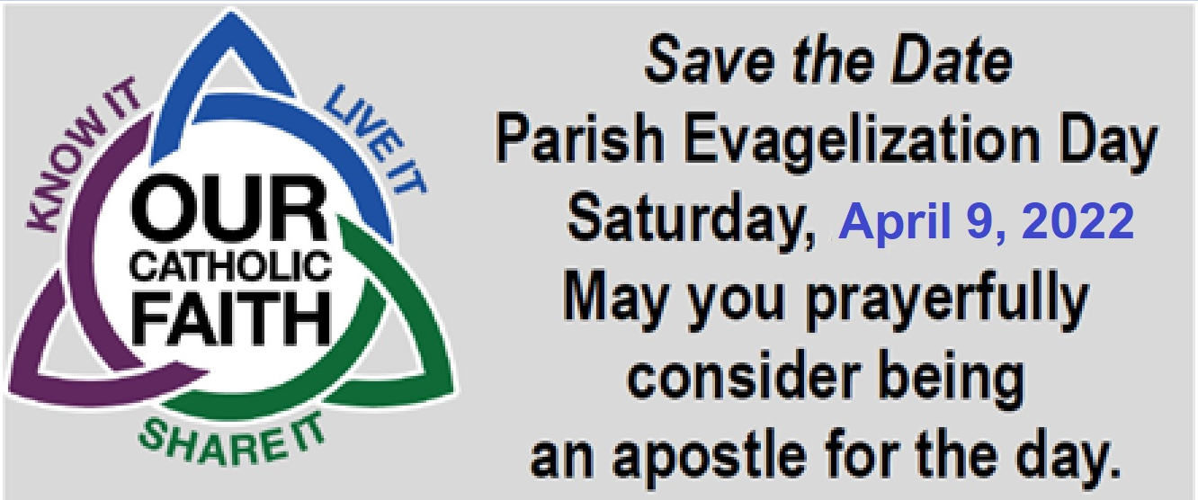

**St. Ignatius Loyola Parish**

New this year! **TELETHON and E-Day**

Event starts with 8:00 AM Mass

Saturday – before Palm Sunday

* Breakfast and Lunch provided.
* No Experience required.
* One Day event commitment.
* There will be a brief Training (Telethon & E-Day)

You may Email: legionofmaryallentown@gmail.com

Or Call Jake Gonzales: 610-670-1429

Cut here ------------------------------------------------------------------------------- Cut here

**St. Ignatius Loyola Parish TELETHON & E-Day Registration**

Before Palm Sunday; **Saturday April 12, 2025**

NAME: _____________________________________________________

Address: ____________________________________________________

Phone: ______________________

[ ] **E-Day participant:** Have Car? Yes ___ No ___

(New workers will be teamed with experienced partner)

First time I’ve done evangelization. Yes ___ No ___

[ ] **TELETHON participant only.**



**St. Ignatius Loyola Parish**

New this year! **TELETHON and E-Day**

Event starts with 8:00 AM Mass

Saturday – before Palm Sunday

* Breakfast and Lunch provided.
* No Experience required.
* One Day event commitment.
* There will be a brief Training (Telethon & E-Day)

You may Email: legionofmaryallentown@gmail.com

Or Call Jake Gonzales: 610-670-1429

Cut here ------------------------------------------------------------------------------- Cut here

**St. Ignatius Loyola Parish TELETHON & E-Day Registration**

Before Palm Sunday; **Saturday April 12, 2025**

NAME: _____________________________________________________

Address: ____________________________________________________

Phone: ______________________

[ ] **E-Day participant:** Have Car? Yes ___ No ___

(New workers will be teamed with experienced partner)

First time I’ve done evangelization. Yes ___ No ___

[ ] **TELETHON participant only.**