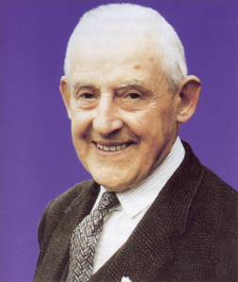 | FRANK DUFF  Founder of the Legion of Mary  Frank Duff was born in Dublin, Ireland, on June 7, 1889. He entered the Civil Service at the age of 18. At 24 he joined the Society of St. Vincent de Paul where he was led to a deeper commitment to his Catholic faith and at the same time he acquired a great sensitivity to the needs of the poor and underprivileged.  Along with a group of Catholic women and Fr. Michael Toher, Dublin Archdiocese, he formed the first praesidium of the Legion of Mary on September 7, 1921. From that date until his death, November 7, 1980, he guided the world-wide extension of the Legion with heroic dedication. He attended the Second Vatican Council as a lay observer.  His profound insights into the role of the Blessed Virgin in the plan of Redemption, as also into the role of the lay faithful in the mission of the Church, are reflected in the Handbook which is almost entirely his composition.
Prayer for the Beatification of the Servant of God Frank Duff
God our Father,
You inspired your servant Frank Duff with a profound insight into the mystery of your Church, the Body of Christ, and of the place of Mary the Mother of Jesus in this mystery.
In his immense desire to share this insight with others and in filial dependence on Mary he formed her Legion to be a sign of her maternal love for the world and a means of enlisting all her children in the Church's evangelising work.
We thank you Father for the benefits accruing to the Church from his courageous and shining faith.
With confidence we beg you that through his intercession you grant the petition we lay before you . . .
We ask too that if it be in accordance with your will, the holiness of his life may be acknowledged by the Church for the glory of your Name, through Christ Our Lord, Amen.

